- When i clicked of Ctrl-Shift -R page gets refreshed and it takes a lot of time, if i hover on line, it shows accounts status but i cant scroll to see which is account is taking time to load 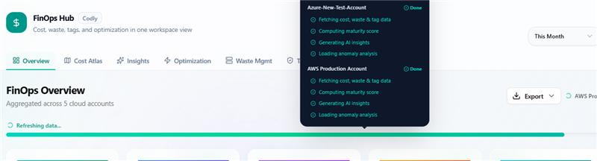

2.
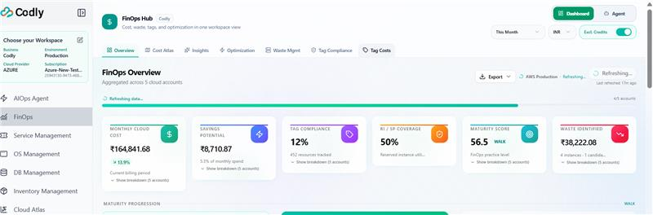
Stuck at refreshing now for 15 minn, and 4/5 accounts done

3.
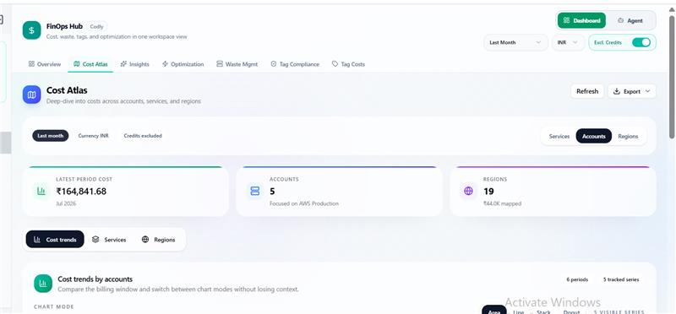
I am expecting when i change it to last month, the cost at first widget should change, i have to scroll down till end of page to see total cost.

4. Region map

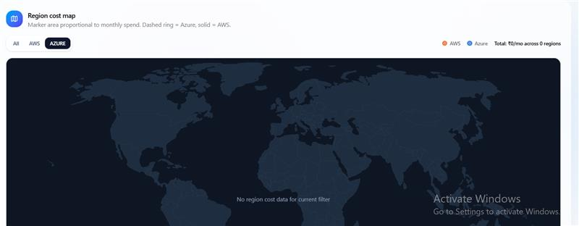

19 regions?? I have serious doubts on it.

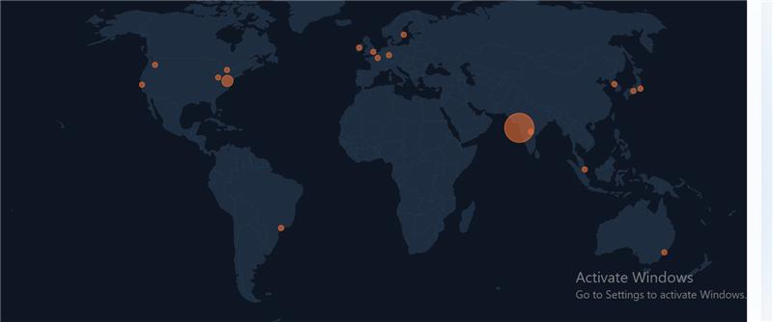

I mean australlia?

5. EXPORT DOC is not good

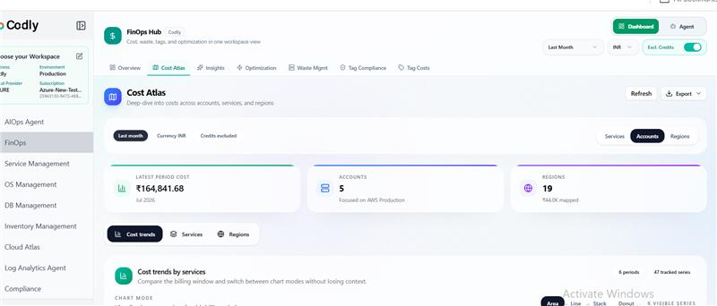
This is page and below is ss of export pdf

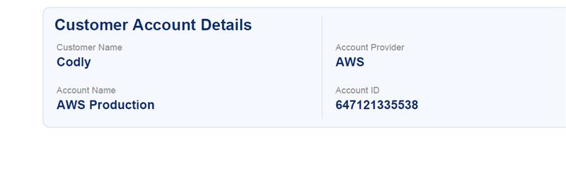

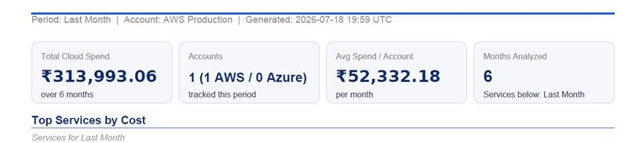

Where is the cost of this month

I have chosen, Azure account in workspace and I am getting aws production account report. And where do i select for which account i need report. This is really disappointing.

6. You can remove More resources in Optimisation as we need to validate the criteria first

7. Optimisation -
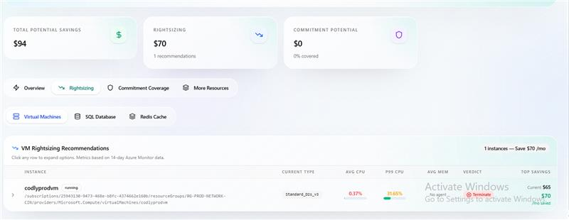

For azure account i see correct numbers

when i select AWS account-

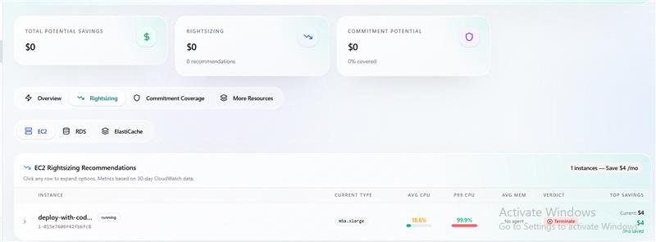

When i chose AWS Test account - Rightsizing shows an option, but cost saving potential is 0

8.
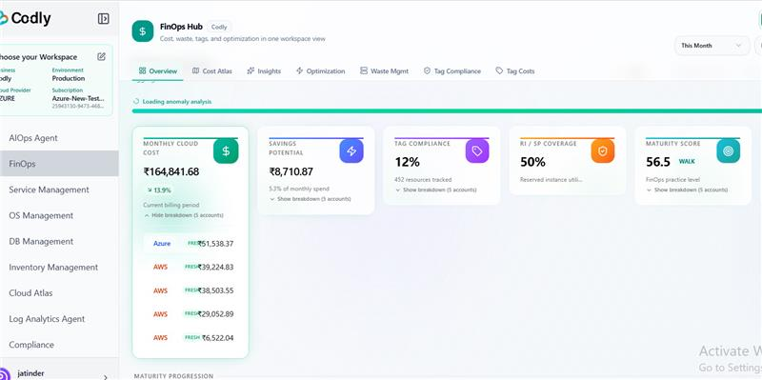

Frotnend - overlap

9. Waste in Overview tab doesn't match with waste management section cost

10. Check in code, region is considered right?
11.
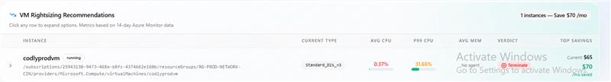
how current is $65 and savng is $70

12. Inconsistencies - Overview tab has Savings potential and waste as same cost

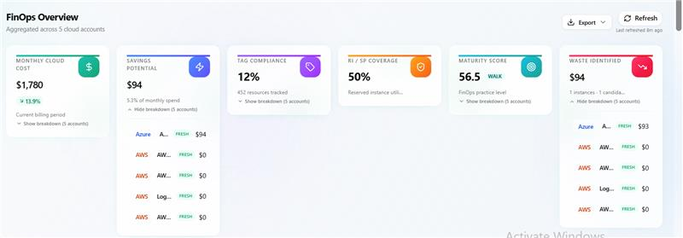

For all AWS accounts: savings are there but widget of saving potential shows 0 only

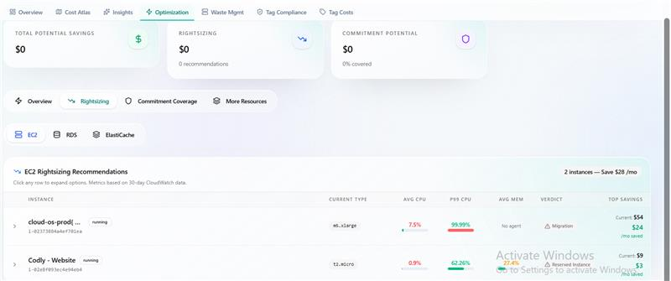

Waste management for AWS accounts is non zero but is shown as zero in Overview page

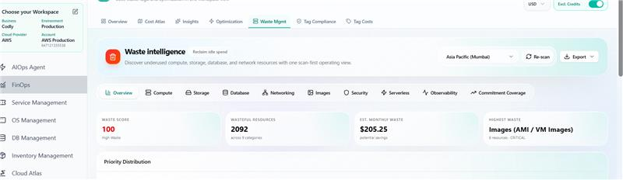

13. Waste Management - Export return a bad data file

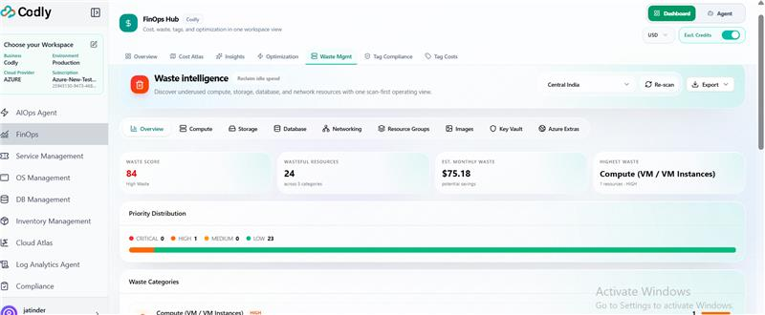

and in report export i get this
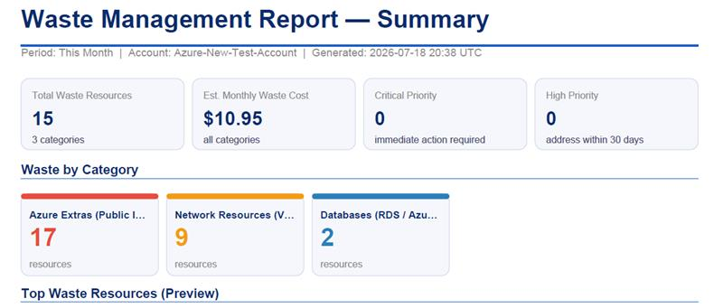

14. Tag Compliance is broken

15. Tag cost i need to benchmark

16. Anomaly agent data doesn't match with dashboard. change template query

As i had promised I have tested beta, I am yet to check admin portal reports

Kindly fix it so that we can send image to customer on Monday.
17. Dashboard n agent cost differ by 1 day for current month , make it consistent
cost of?

which cost?
Cost analytics current month cost If I see July number on dashboard n run a query on agent to show cost of this month There is a 1 day difference

